# **Sprint 2**

Total Story Points: 36 Total Hours Estimate:

Estimated Velocity: ~10  
Actual Velocity: 26 Total Hours Taken:

## **Editing the Databases - Story ID: 28**

|  |  |  |  |
| --- | --- | --- | --- |
| Task ID | Task Description | Estimate | Taken |
| 1 | HTML page interface display | 3 | 3 |
| 2 | Edit database function | 6 | 1 |
| 3 | Delete database function | 6 | 1 |
| 4 | Search the database function | 10 | 2 |
| 5 | Filter the database function | 8 | 8 |
| 6 | Verify story is complete (unit tests) | 6 | 2 |
|  | Story Points: 8 Total Hours: | 39 | 17 |

## **Potential Employee Contact - Story ID: 24**

|  |  |  |  |
| --- | --- | --- | --- |
| Task ID | Task Description | Estimate | Taken |
| 1 | HTML page interface display | 3 | 3 |
| 2 | Pass form data to database | 5 | 4 |
| 3 | Upload resume file to database through admin | 5 | 7 |
| 4 | Verify story is complete (unit tests) | 5 | 8 |
|  | Story Points: 4 Total Hours: | 18 | 22 |

## **Student Account Creation - Story ID: 1**

|  |  |  |  |
| --- | --- | --- | --- |
| Task ID | Task Description | Estimate | Taken |
| 1 | HTML page interface display | 3 | 4 |
| 2 | Save form submission data to database | 5 | 7 |
| 3 | Create student login in Django | 2 | 2 |
| 4 | Create an age check functionality | 3 | 8 |
| 5 | Verify story is complete (unit tests) | 5 | 8 |
|  | Story Points: 4 Total Hours: | 18 | 25 |

## **Book a Lesson - Story ID: 4**

|  |  |  |  |
| --- | --- | --- | --- |
| Task ID | Task Description | Estimate | Taken |
| 1 | HTML page interface display - including backend | 4 | 2 |
| 2 | Search user database to check new or old student | 2 | 1 |
| 3 | Design time schedule for classes | 8 | 13 |
| 4 | Send data to owner via database | 5 | 9 |
| 5 | Verify story is complete (unit tests) | 8 | 3 |
|  | Story Points: 8 Total Hours: | 27 | 28 |

## 

## **About us - Story ID: 34 - Added in Sprint 2**

|  |  |  |  |
| --- | --- | --- | --- |
| Task ID | Task Description | Estimate | Taken |
| 1 | HTML page interface display | 1 | 2 |
| 2 | Create photo Gallery on html display | 4 | NF(2) |
| 3 | Being able to edit the page | 5 | NF(1) |
| 4 | Verify story is complete (unit tests) | 1 | - |
|  | Story Points: 2 Total Hours: | 11 | - |

## 

## **Contact us - Story ID: 36 - Added in Sprint 2**

|  |  |  |  |
| --- | --- | --- | --- |
| Task ID | Task Description | Estimate | Taken |
| 1 | HTML page interface display | 1 | 2 |
| 2 | Create links to Profile pages | 4 | 1 |
| 3 | Create facebook link | 1 | 1 |
| 4 | Verify story is complete (unit tests) | 1 | 1 |
|  | Story Points: 2 Total Hours: | 7 | 4 |

## 

## **Owner Contract Approval - Story ID: - Incomplete due to dependency on book a lesson**

|  |  |  |  |
| --- | --- | --- | --- |
| Task ID | Task Description | Estimate | Taken |
| 1 | HTML page interface display - backend | 8 | - |
| 2 | Create a function to change the details within the contract to a downloadable pdf format | 5 | - |
| 3 | When the contract is approved, remove lesson time from the available time DB for the student relevant to the contract | 4 | - |
| 4 | Verify story is complete (unit tests) | 8 | - |
|  | Story Points: 8 Total Hours: |  | - |

# 

## Changes to sprint plan:

## **Redefined stories in sprint 2 Editing the Databases - Story ID: 28**

|  |  |  |  |
| --- | --- | --- | --- |
| Task ID | Task Description | Estimate | Taken |
| 1 | HTML page interface display | 3 |  |
| 2 | Edit database function | 6 |  |
| 3 | Delete database function | 6 |  |
| 4 | Search the database function | 10 |  |
| 5 | Filter the database function | 8 |  |
| 6 | Verify story is complete (unit tests) | 6 |  |
|  | Story Points: 8 Total Hours: | 39 |  |

# **Added stories in sprint 2 Contact us - Story ID:**

|  |  |  |  |
| --- | --- | --- | --- |
| Task ID | Task Description | Estimate | Taken |
| 1 | HTML page interface display | 1 |  |
| 2 | Create links to Profile pages | 4 |  |
| 3 | Create facebook link | 1 |  |
| 4 | Verify story is complete (unit tests) | 1 |  |
|  | Story Points: 2 Total Hours: | 7 |  |

## **About us - Story ID:**

|  |  |  |  |
| --- | --- | --- | --- |
| Task ID | Task Description | Estimate | Taken |
| 1 | HTML page interface display | 1 |  |
| 2 | Create photo Gallery on html display | 4 |  |
| 3 | Being able to edit the page | 5 |  |
| 4 | Verify story is complete (unit tests) | 1 |  |
|  | Story Points: 2 Total Hours: | 11 |  |

06/05/2018 - Editing the databases Finalized- **Chris Haywood(Scrum Master)** meeting with Isaiah Dunrobin(Product owner) and team

Continuing on from the last sprint I was tasked with researching how to implement the “Editing the databases” story(ID:28) to a standard as closely consistent with the current acceptance criteria as possible. As much of this story functionality was created previously in sprint 1 through the development of other stories. The group hopes to use the django admin functionality to complete this story but were unsure if they would be able to meet the stories current criteria. I found through my research that I’d be able to meet almost all the criteria by using Django’s own ModelAdmin class but using this implementation would be slightly different from the method specified in the acceptance criteria. This differences however were essentially minor and related to the navigation of the webpage.

As such I reported my findings to the group and suggested making changes to the acceptance criteria Product Owner. These changes were minor and you can see the old and new requirements in the following screen shots.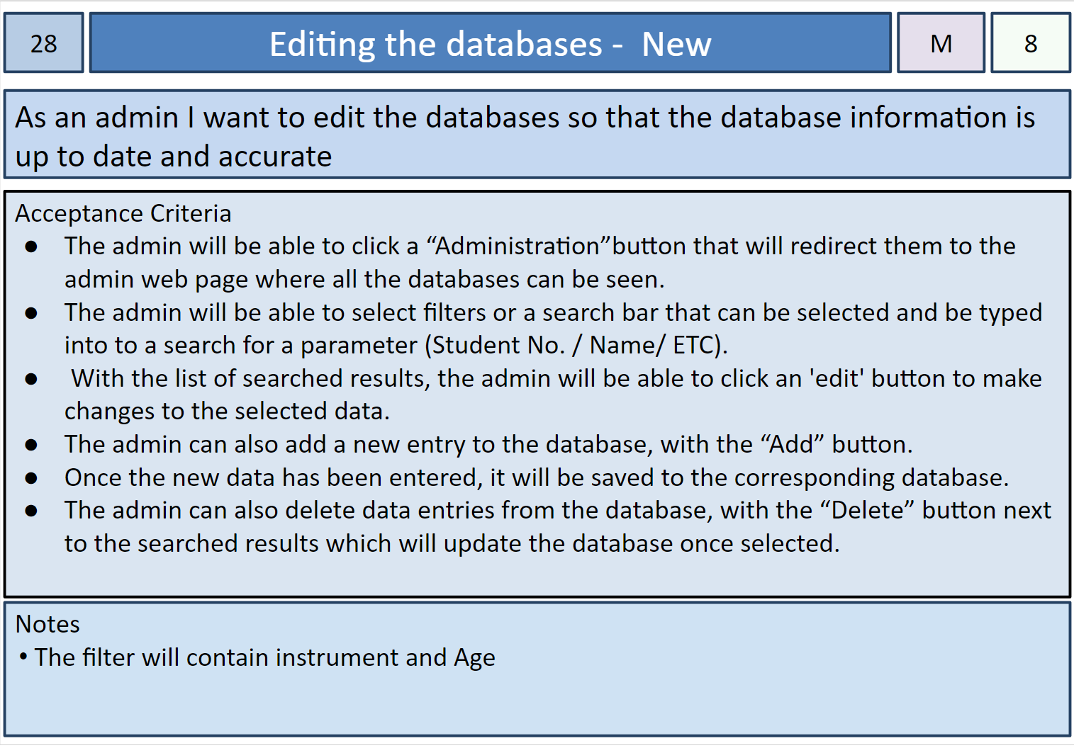

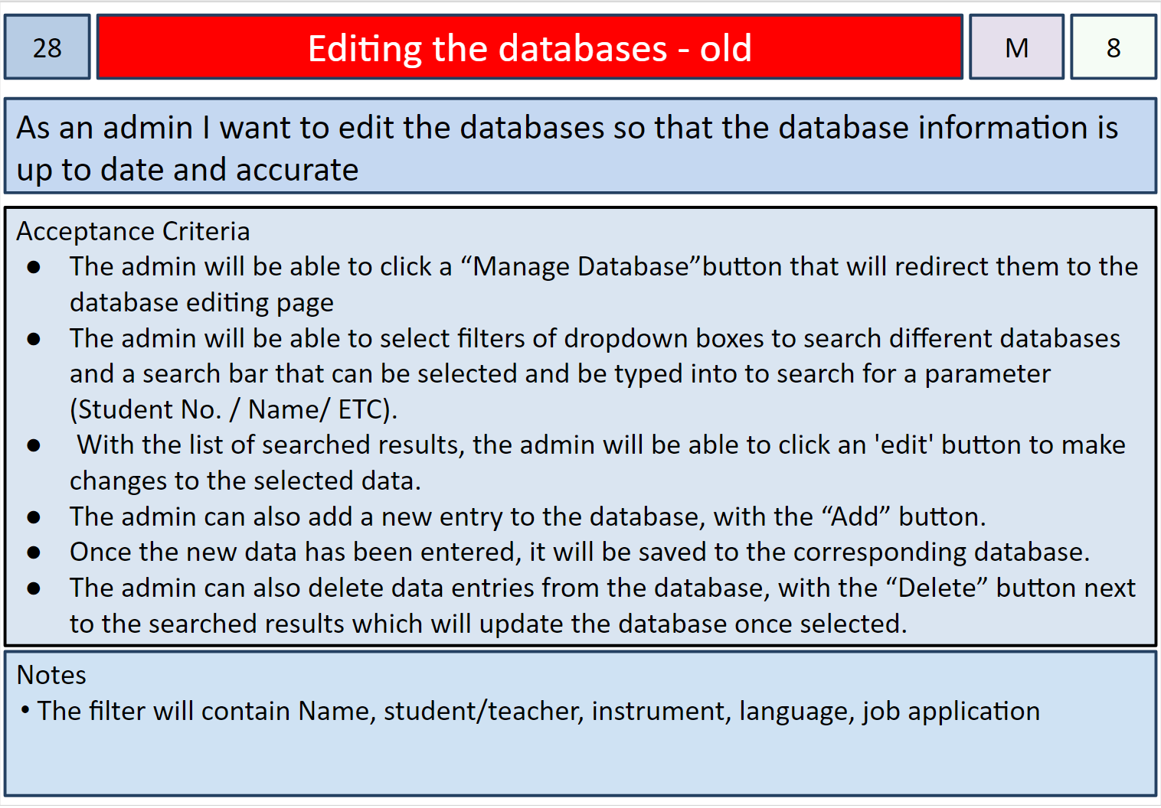

16/05/2018 - ‘About Us’ and ‘Contact Us’ stories moved up into sprint 2  
**Chris Haywood(Scrum Master)** meeting with Ramon Dickins(Product owner) and team

During the second week of the sprint 2, we found that after the initialize tasks for the sprint 2 were wrapping up and being finalized there were problems with moving the available members to work on the ‘Book a lesson’ and ‘Owner contract approval’ stories. The main issue we found was that the “Owner contract approval” story depended on the ‘Book a lesson’ features that were still being implemented. Aswell the ‘Book a lesson’ story members were running into some difficulties with implementing the story, as their were some issues with django’s framework that the group was struggling to fix. Unfortunately because of the skill level required to fix it being beyond the available members abilities, they were unable to help resolve these issues.

To make sure we used our team members resources efficiently, I suggested to the group that we could move some less complicated stories from a later release into our current release that Rory and Isaiah could develop. The current design and implementation of the home page has links to a “Contact Us” and “About Us” page that are yet to be created and I identified these stories as appearing to be simple to implement with many examples and tutorial resources available. Due to these factors, I brought these stories forward to Rory and Isaiah and asked them if they could implement these stories and if they would be a good addition to the website currently as they play the role of the product owner. They agreed with this plan and will try to implement them before the first release.

The following screen shots show the story cards that were brought up into this sprint:

